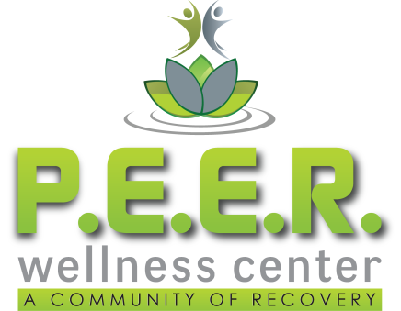

Transportation Program
Policy & Procedure
Effective 10/16/15

Transportation to recovery, treatment, and employment appointments has been identified as a barrier to recovery. The purpose of the PEER Wellness Center, Inc. Transportation Program is to remove barriers to recovery by providing recovery-related transportation to individuals in situations where no other transportation is available. It does not duplicate existing resources that are available to Peers. Instead, the PEER Wellness Center Transportation Program strives to fill the gap of transportation needs when no other options are available.
PEER Wellness Center, Inc. will contract with specific individuals to provide transportation under this program. Reimbursement will be provided once a week at the federal rate of .55/mile. In order to be reimbursed for mileage, Contracted drivers will meet the following criteria:
- Contracted driver must have completed and signed a Memorandum of Agreement.
- Contracted driver must, at all times, have a reliable vehicle, a valid Driver’s License, carry Liability Insurance on their vehicle, and their vehicle must be properly registered.
- Contracted drivers must keep a mileage log that specifies the date, time, person, locations, and purpose of each reimbursable transport that includes beginning and ending mileage.
- Contracted drivers must adhere to the Transportation Program Rules and Guidelines at all times.

PWC Transportation Guidelines
In order to effectively meet the transportation needs of individuals in recovery, the following program guidelines have been implemented:
- Requests for transportation must be scheduled a minimum of 24 hours in advance.
  - Requests are made in writing by filling out a Transportation Request Form.
  - Certain situations may arise where 24 hour notice is not possible. Exceptions will be considered on a case-by-case basis. Any exceptions to this rule must be authorized in writing by a PEER Wellness Center staff member before the transport occurs.
- A fee of $2 will be charged for every transport.
  - Payment must be received the same day unless other arrangements have been made in advance with PEER Wellness Center Management.
  - Volunteer hours in a specific volunteer capacity may be considered as payment for transportation. In order to qualify for this exemption, a Fee Exemption Form must be completed and signed by both the Peer and a PEER Wellness Center staff member before transport is provided.
- A Release of Liability form must be signed by the Peer requesting transportation under this program. No exceptions are allowed.
- Individuals receiving transport under this program must agree to abide by the following rules:
  - Individuals will be ready 15 minutes prior to the scheduled pick-up time.
  - Individuals will not be under the influence of or have in their possession any illicit drugs or alcohol.
  - Individuals will not have in their possession weapons of any kind.
  - Individuals who violate safety standards, who cause hazardous or dangerous situations, or who fail to report hazardous or dangerous situations during transport may be subject to temporary or permanent removal from the Transportation Program.

